

Test Delivery Client Installer

Table of Contents

Table of Contents 2
Overview 3
CVS Modules 4
Preparing the Artifacts 5
Preparing application-tdc 5
Preparing application-tdcbootstrap 6
Preparing application-tdcinstall 6
Creating the Installer 8

Overview
This document describes the steps necessary to create the installer used by the Online Assessment System’s Test Delivery Client.

CVS Modules
The following CVS modules are needed in order to create the Test Delivery Client’s installer:

- application-tdc
- application-tdcbootstrap
- application-tdcinstall

The application-tdc module contains all the core components of the test delivery client. The Lockdown Browser, the Servlet Container, and the web application to be executed within the Servlet Container are the major components within this CVS module.

The application-tdcbootstrap module contains the “glue” component that is responsible for launching the various core components within the application-tdc module. It is responsible for setting up the student’s workstation to properly run the core components within the application-tdc module.

The application-tdcinstall module contains the source code for InstallAnywhere, the software used to create our installer software. (See http://www.macrovision.com/ for additional information). In addition, there is java package structure within this module that allows for the creation of custom rules and actions to be used by InstallAnywhere’s software.

Preparing the Artifacts

Preparing application-tdc
To prepare the application-tdc module for inclusion in the installer’s artifacts folder, run the ant build task with the target of “dist”.

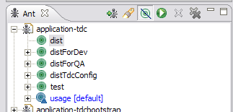

This will create a dist folder containing a clean folder structure with appropriate production configuration for all components.

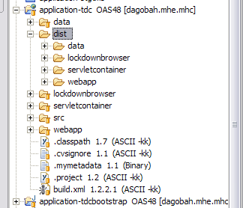

Preparing application-tdcbootstrap
To prepare the application-tdcbootstrap module for inclusion in the installer’s artifacts folder, run the ant build task with the target of “build”.

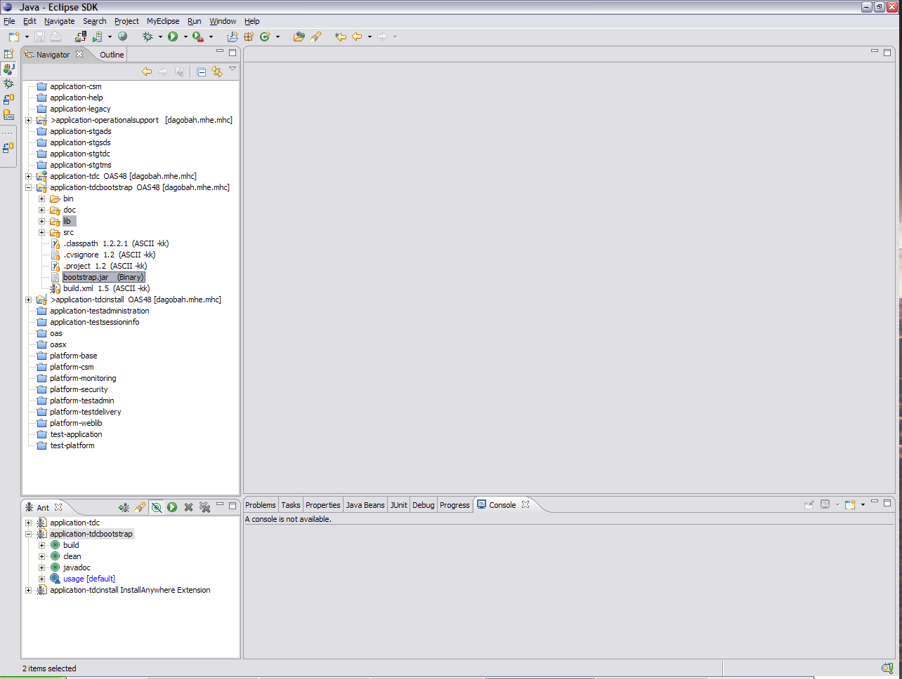

This will create the bootstrap.jar artifact to be included in the installer.

Preparing application-tdcinstall
With the successful completion of preparing the application-tdc and application-tdcbootstrap applications, the appropriate artifacts need to be copied over to the application-tdcinstall folder. Remove the following files within the artifacts folder within the application-tdcinstall to guarantee the current and pruned copy of the application-tdc and application-tdcbootstrap artifacts:

- data
- etc
- lockdownbrowser
- servletcontainer
- webapp
- bootstrap.jar

Do not remove the utilities folder since it contains, well, utilities for use by the installer. In addition, do not remove the misc folder since contains miscellaneous artifacts from the application-tdcinstall module itself.

After the files have been removed, please copy over the contents of the dist folder within the application-tdc module over to the artifacts folder within the application-tdcinstall module. Next, copy over the contents of the lib folder and bootstrap.jar file from the application-tdcbootstrap module over to the application-tdcinstall module as well.

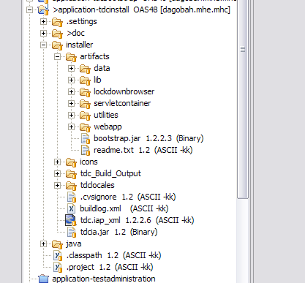

At this point, all artifacts from the application-tdc and application-tdcbootstrap modules have been transferred over and are now ready for the installer.

Creating the Installer
To create the installer, an ant script is used by Cruise Control to invoke InstallAnywhere from the command line to build the artifacts from the tdc.iap_xml source file. For custom installers, XSL files are used by the ant script to create appropriate installers. These XSL files are located within the antxsl folder. However, if any change to the installer script is needed, please be sure to keep these files in mind.

For the remaining tasks, please be sure to consult InstallAnywhere documentation on how to create the installer.

Appendix A – InstallAnywhere Custom Rules and Actions
To create custom rules and actions, consult InstallAnywhere documentation. However, for existing custom rules and actions that are currently employed in the installer, see the package structure under the java folder within application-tdcinstall.

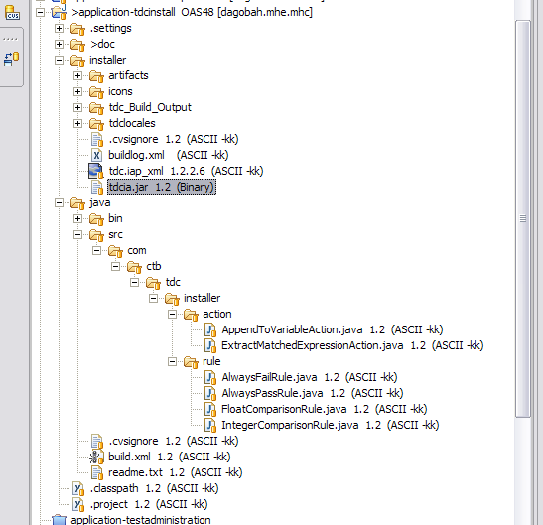

To build the tdcia.jar that is used by the installer, run the ant build script located within the java folder with the build task.

